**Topic Name:** Real time network monitoring and Traffic Analysis in VANET

**Group Member:**  1. Fabiha Tasnim 20-43426-1

2. MD. Sadik Hossain Chowdhury 20-43427-1

**Introduction:**

Vehicular Ad hoc Networks (VANETs) are a specific category of Mobile Ad hoc Networks (MANETs) that enable communication between vehicles (V2V - Vehicle-to-Vehicle) and between vehicles and infrastructure (V2I - Vehicle-to-Infrastructure). VANETs are a crucial component of Intelligent Transportation Systems (ITS) and play a vital role in enhancing road safety, traffic efficiency, and overall driving experience. Real-time network monitoring and traffic analysis in VANETs are essential aspects of managing and optimizing these dynamic vehicular networks. As vehicles communicate with each other and the surrounding infrastructure, a vast amount of data is generated, including location information, speed, acceleration, braking, road conditions, and more. Analyzing this data in real-time allows stakeholders such as traffic managers, city planners, and emergency services to make informed decisions and take appropriate actions promptly. In real-time network monitoring and traffic analysis in VANETs will face challenges that will be worked on this paper that are high mobility, scalability, data accuracy and trustworthiness and privacy and security. Extra approaches will be added to vehicles to contact with every vehicle that will be needed to connect as ambulance, police cars, fire brigades vehicle and more. By leveraging the potential of VANETs and advanced data analytics, smart cities and transportation systems can move towards a safer and more connected future.

**Objective:**

The key objectives of real-time network monitoring and traffic analysis in VANETs are:

1. To enhance the traffic safety
2. To congestion of management
3. To improve the efficiency of traffic
4. To response emergency as medical, safety and more
5. To make decision for data-driven

**Literature Review:**

A Comprehensive Survey on VANET Security Services in Traffic Management System by Muhammad Sameer Sheikh and Jun Liang (2019)

1. Traffic Accident Prediction Techniques in Vehicular Ad-hoc Network: A Survey by Shweta Shendekar, Samrat Thorat and Dinesh Rojatkar (2021)
2. Vehicle To Everything (V2x) Communication Protocol By Using Vehicular Ad-Hoc Network By Muhammad Ahtsam Naeem , Xiaolin Jia , Muhammad Asim Saleem ,Wasif Akbar , Afzaal Hussain , Shahbaz Nazir and Khwaja Mutahir Ahmad (2020)
3. A Survey on Recent Advances in Vehicular Network Security, Trust, and Privacy by Zhaojun Lu, Gang Qu and Zhenglin Liu (2018)
4. VANET Routing Protocols: Review, Implementation and Analysis By Rizwan Ghori, Muhammad, Ali Safa Sadiq, and Abdul Ghani. Journal of Physics: Conference Series. Vol. 1049. (2018).

**Discussion of Users, Features, methods and idea of the topics:**

**Users:**

The users of real-time network monitoring and traffic analysis in VANET can be categorized into the following groups:

1. Traffic managers and planners
2. Emergency services
3. Vehicle manufacturers
4. City planners and administrators
5. General public

**Features:**

The features of real-time network monitoring and traffic analysis in VANET can be categorized into the following:

1. Real-time data collection
2. Traffic flow analysis
3. Safety monitoring
4. Route optimization
5. Privacy and security
6. Incident detection
7. Minimize incident
8. Emergency detection
9. Data visualization
10. Emergency assistance

**Methods:**

The methods of real-time network monitoring and traffic analysis in VANET can be categorized into the following:

1. Data collection and processing
2. Data analytics
3. Communication protocols
4. Map matching
5. Anomaly detection

**Ideas:**

The ideas of real-time network monitoring and traffic analysis in VANET can be categorized into the following:

1. Dynamic traffic light control
2. Traffic incident management
3. Predictive maintenance
4. Eco-friendly routing
5. Intelligent intersection management
6. Public information systems
7. Protect privacy and security
8. Cooperative collision avoidance
9. Emergency assistance management
10. Future mobility innovations

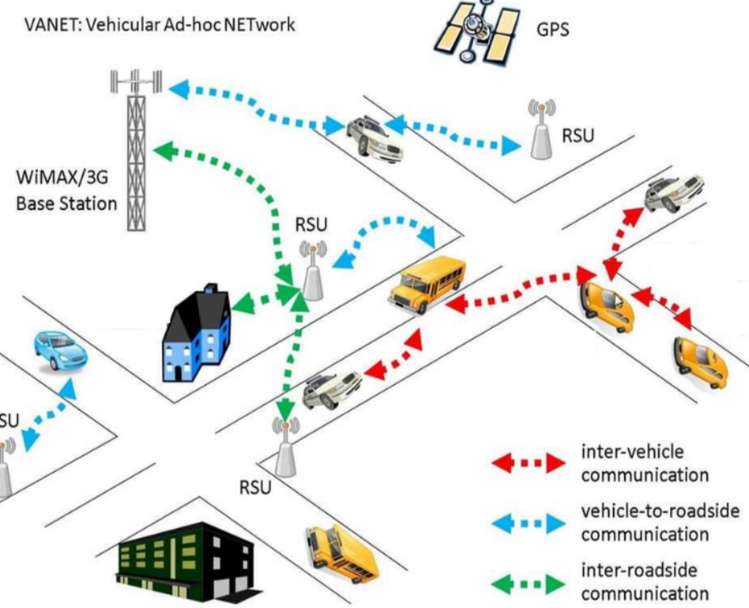

**Conclusion:**

Real-time network monitoring and traffic analysis in Vehicular Ad hoc Networks (VANETs) play a critical role in shaping the future of intelligent transportation systems and smart cities. By harnessing the power of advanced data analytics and communication technologies, these systems offer a range of benefits for various stakeholders and general public. Real-time network monitoring and Traffic Analysis in VANET is also facing challenges, including data privacy and security concerns, scalability issues, and the need for efficient communication protocols to handle the rapid mobility of vehicles.

In conclusion, the integration of real-time monitoring and traffic analysis into VANETs presents a transformative opportunity to create safer, more efficient, and sustainable transportation systems. As technology continues to evolve, these systems will play an increasingly vital role in shaping the future of mobility and smart cities worldwide. It requires collaboration among researchers, policymakers, industry stakeholders, and the public to harness the full potential of VANETs for a smarter and connected future.

**References:**

1. Sheikh, Muhammad Sameer, and Jun Liang. "A comprehensive survey on VANET security services in traffic management system." *Wireless Communications and Mobile Computing* 2019 (2019): 1-23.
2. Shendekar, Shweta, Samrat Thorat, and Dinesh Rojatkar. "Traffic Accident Prediction Techniques in Vehicular Ad-hoc Network: A Survey." *2021 5th International Conference on Trends in Electronics and Informatics (ICOEI)*. IEEE, 2021.
3. Srivastava, A., A. Prakash, and R. Tripathi. "Location based routing protocols in VANET: issues and existing solutions. Veh Commun 23: 100231." (2020).
4. Naeem, Muhammad Ahtsam, et al. "Vehicle to everything (V2X) communication protocol by using vehicular AD-HOC network." *2020 17th International Computer Conference on Wavelet Active Media Technology and Information Processing (ICCWAMTIP)*. IEEE, 2020.
5. Lu, Zhaojun, Gang Qu, and Zhenglin Liu. "A survey on recent advances in vehicular network security, trust, and privacy." *IEEE Transactions on Intelligent Transportation Systems* 20.2 (2018): 760-776.